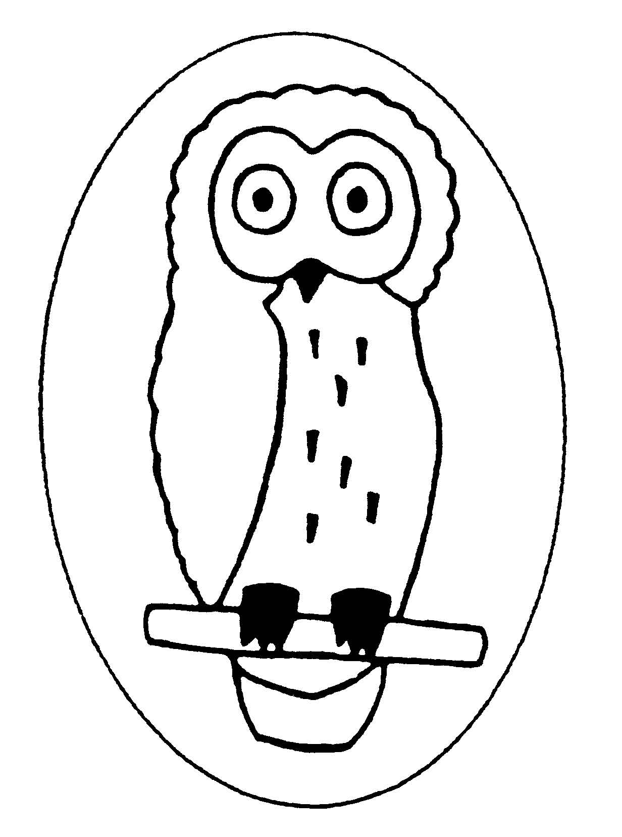
Dry Sandford County Primary School
Lashford Lane, Dry Sandford, Abingdon, Oxon, OX13 6EE
Tel/Fax: 01865 730 432
headteacher.2565@dry-sandford.oxon.sch.uk
office.2565@dry-sandford.oxon.sch.uk
www.dry-sandford.oxon.sch.uk

Headteacher: Mrs Katie Friday, BEd (Hons), QTS

Friday 19th January 2024

Dear Parents,

Happy New Year! We are already into the new term and our curriculum is as follows:

Maths Addition, subtraction, multiplication and division using formal methods, decimals on a number line, conversion of fractions, decimals, percentages, area, place value, number sequences, number facts and bonds.
English Explanation, story writing, poetry, plays; spelling, grammar and handwriting
Science Light, Electricity
RE Christianity and Islam
PHSE Dreams and Goals, Healthy Me
Humanities Ancient Greece, UK cities & counties, European countries & atlas work
Art & DT Stained glass windows (Greek style), Greek masks
Music Songs to accompany a performance
PE Dance, Gymnastics

The children have a new Reading Record book where spellings are recorded for additional practice at home. As a reminder of homework, the following is recommended to maintain a routine of good practice. The more you can encourage and support this suggested timetable, the better. We are pleased to report that by the end of last term, at least 75% of the class were regularly doing Doodlemaths and their work in class benefitted from this.
We are fortunate to be able to go to Cothill for use of their brand new sports hall again this term. We walk down there every Friday and need to leave school at 8.45 to take full advantage of our time slot. Therefore, could the children please continue to come to school in PE kit on Fridays.

Monday | Reading (15-20 mins) |  | Spelling / vocab extension (10 mins) | 30 mins
Tuesday |  | Doodlemaths (10 mins) | Spelling / vocab extension (10 mins) | 20 mins
Wednesday | Reading (15-20 mins) | Doodlemaths (10 mins) |  | 30 mins
Thursday | Reading (15-20 mins) | Doodlemaths (10 mins) | Spelling / vocab extension (10 mins) | 40 mins
Friday | (Book review: 15 mins) | Doodlemaths (10 mins) |  | 25 mins

Some additional time will be given to Reading, Maths and Grammar papers, particularly for Year 6, as this is the term we begin preparing for our ‘National Showing Off’ week in May.
Again, thank you for your support in the time you spend on the ‘over and above’ - it all helps.

Yours sincerely,

Miss Stirling and Mrs Crothers

