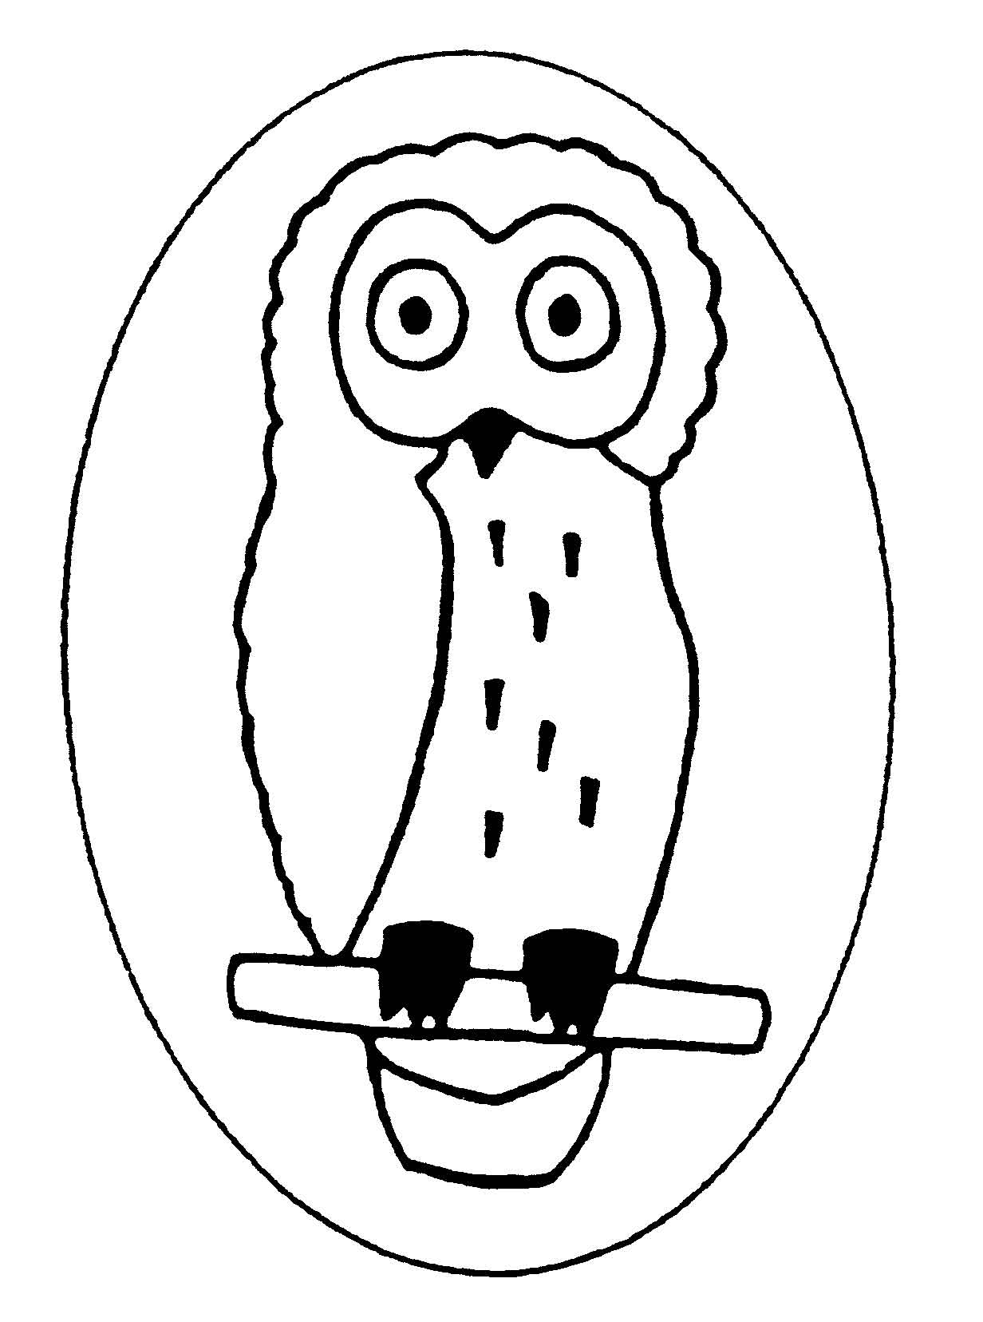
Dry Sandford County Primary School
Lashford Lane, Dry Sandford, Abingdon, Oxon, OX13 6EE
Tel/Fax: 01865 730 432
head.2565@dry-sandford.oxon.sch
office.2565@dry-sandford.oxon.sch.uk
www.dry-sandford.oxon.sch.uk

Headteacher: Mrs Lisa Moorhouse B Sc (Hons), NPQH
Friday 8th September 2023

Dear Parents,

Snowy Owls Curriculum Letter

Welcome to the autumn term
Snowy Owls have had a busy first few days back and it has been great getting to know all the year 3 children. We have an exciting term planned as our new topic is ‘Stone Age to Iron Age’.

We will be covering the following areas in the curriculum in the autumn term:
Maths | Place value, four number operations (addition, subtraction, multiplication and division)
English | Setting and character descriptions, explanations, newspaper reports, Christmas themed poetry, Spelling, grammar and handwriting
Science | Rocks, fossils and soil, mouth, teeth and digestion
RE | Sikhism and Christianity
PSHE | Being me in my world and celebrating differences
Humanities | History of the Stone Age to the Iron Age
Art and DT | Stone Age artwork, drawing and painting, 3D designs and models
PE | Invasion games (netball) and swimming
Music | Singing, playing the recorder, listening to music and creating music

PE this term will be on Wednesdays, but we may have an extra session at some point during the week so please can the children keep their kits in school every day. Can you ensure your child has a PE top, black bottoms and trainers. Jewellery is not allowed and earrings should be removed or covered with a plaster for safety during PE sessions. It is also important that the children have indoor and outdoor shoes each day. After the October half term, we will begin our swimming sessions.

Each week the children have reading, maths, spelling homework. The spellings for the whole half term will be sent out on Monday and the spelling tests will be on Mondays. Please ask for another sheet if you need one. The maths homework is all online and is set on Friday afternoons.
Please see the table below for a suggestion on how to complete:
 | Reading | Doodle Maths (online) | Spelling
Monday | 10 mins | 15 mins | 10 mins
Tuesday | 10 mins | 15 mins
Wednesday | 10 mins |  | 10 mins
Thursday | 10 mins | 15 mins
Friday | 10 mins |  | 10 mins
Regular reading each day at home will really help support your child with all areas of learning. There should be 5 brief summaries of reading per week and the children can record their own comments to say what has happened in the section of story they have read and then an adult should sign once a week. The Year 3 book changing day is Mondays and Wednesdays and the Year 4 book changing day is Tuesdays and Thursdays. Please check your child’s book bag daily for letters and other pieces of information.

Thank you very much for your support,
Miss N Chandler

