Dry Sandford Primary School
Sex/ Relationships and Personal Social and Health Education Policy
Name of school: Dry Sandford Primary School
Date of policy: November 2021
Member of staff responsible: Lisa Moorhouse, Anne Platt
Member of Governing Body with designated responsibility: David Murphy
Review Date: (every two years or at times of change)
The Policy Statement: Definition of SRE
Definition:
It is the lifelong learning about physical, moral and emotional development. It is about understanding the importance of marriage and family, stable and loving relationships, respect, love and care. It is also about teaching of sex, sexuality and sexual health. It is not about the promotion of sexual orientation or sexual activity- this would be inappropriate teaching ( DfEE Guidance 0116/2000)
https://www.gov.uk/government/publications/sex-and-relationship-education
Legal Requirements:
Dry Sandford School will ensure:
- That the governing body of the school keeps an up to date SRE Policy that describes content and the organisation of SRE provided outside the national curriculum science order.
- Parents/Carers have the right to withdraw their children from SRE lessons.
Other related Policies and Documents
The RSE Policy will be linked to the following policies:
- Confidentiality Policy
- PSHE Policy
- Safeguarding Children Policy
- SEN Policy
- Anti-bullying Policy
- E-safety Policy
- Behaviour for Learning Policy (Restorative Practices)

The Process of Policy Development and Consultation
The development of this policy has included consultation with:
- Governors, staff and parents.
- Local support agencies including school nurse.
The SRE programme aims
Dry Sandford Primary School aims to provide young people with:

We aim to develop in out pupils an understanding of the physical, biological, emotional, social, spiritual, legal and moral aspects of sex and sexuality. We teach SRE within the wider context of building self-esteem, emotional well-being, relationships and healthy lives beginning in the early years through to year 6. This prepares our pupils for the opportunities, responsibilities and experiences of adult life.
Exemplar KS1 and 2 learning outcomes – these are all in relation to pupil maturity and age- have three main elements (taken from DFE Guidance):

Attitudes and Values
- learning the importance of values and individual conscience and moral considerations;
- learning the value of family life, marriage, and stable and loving relationships for
the nurture of children;
- learning the value of respect, love and care;
- exploring, considering and understanding moral dilemmas; and
- developing critical thinking as part of decision-making.
Personal and Social Skills
- learning to manage emotions and relationships confidently and sensitively;
- developing self-respect and empathy for others;
- learning to make choices based on an understanding of difference and with an
absence of prejudice;
- developing an appreciation of the consequences of choices made;
- managing conflict; and
- learning how to recognise and avoid exploitation and abuse.
Knowledge and Understanding
- learning and understanding physical development at appropriate stages;
- Development of babies during the nine months of pregnancy.

Moral and values Framework
At Dry Sandford Primary School SRE is underpinned by the ethos and values of our school and we uphold it as an entitlement for all our pupils. We recognise the need to work as a whole school community to ensure and shared understanding of SRE and the values underpinning it and to deliver an effective programme that meets the needs of our pupils.

Our school teaches SRE within the following moral and values framework based on the following principles:
Restorative ethos and practices including:
- Self respect
- Respect and tolerance towards others who may have different backgrounds, cultures, feelings, views and sexuality.
- An awareness of the way others feel.
- Mutual support an co-operation.
- Honesty and openness.
- The acceptance of the responsibility for and the consequence of personal actions.
- The right of people to hold their own views within the boundaries of respect for the rights of others.
- The right not to be abused by or taken advantage of by other people.
- The right to accurate information about relationships.
- The value of stable loving relationships.

Content of the SRE Programme
Dry Sandford Primary School delivers SRE through:
- Jigsaw PSHCE delivered by teachers, Headteacher and HLTA.
- Assemblies and Circle Times delivered by all teachers
- Quality assured external agencies/ visitors, who are used to enhance the PSE and SRE programme.
- Activities linked with Restorative Approaches.
- Individual and group sessions to do with friendships, settling in to school and relationships.
Dry Sandford Primary School teaches SRE through:
- A wide range of teaching methods will be used to enable students to actively participate in their own learning.
- Using a variety of active learning methods: quizzes, case studies, research, role play, books including stories, video and small group discussion.
Dry Sandford Primary School ensures SRE CPD through:
- Guidance and training from the Local Authority.
- Annual attendance of Anti-bullying conference.
- Cascaded training by qualified staff regarding Restorative practices (there are currently 2 in the school who have the 4 day qualification.

Outline of the SRE programme
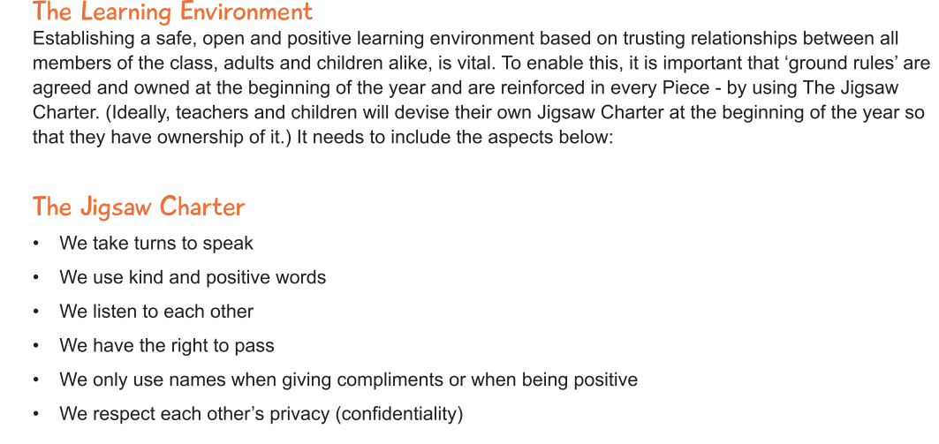

TOPIC 1 IS ‘BEING ME IN MY WORLD’
This focuses on personalised learning about themselves, the school community, families and the wider world including global learning.

Other topics are outlined on the next pages…
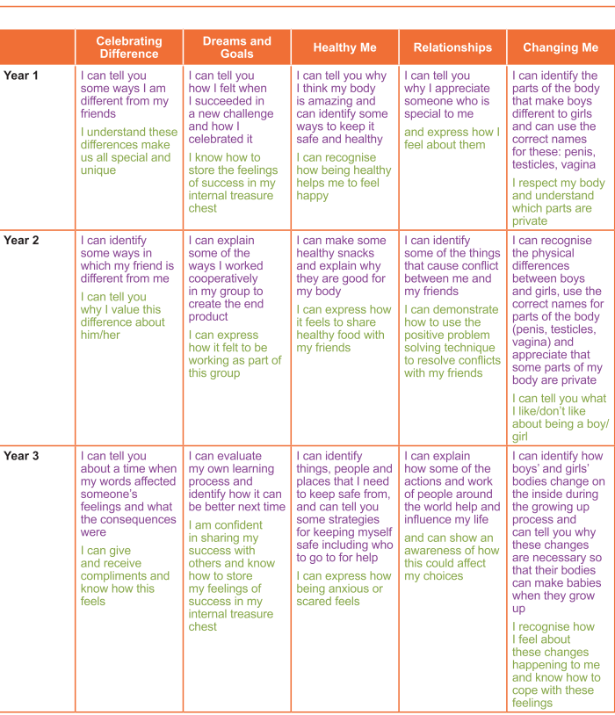

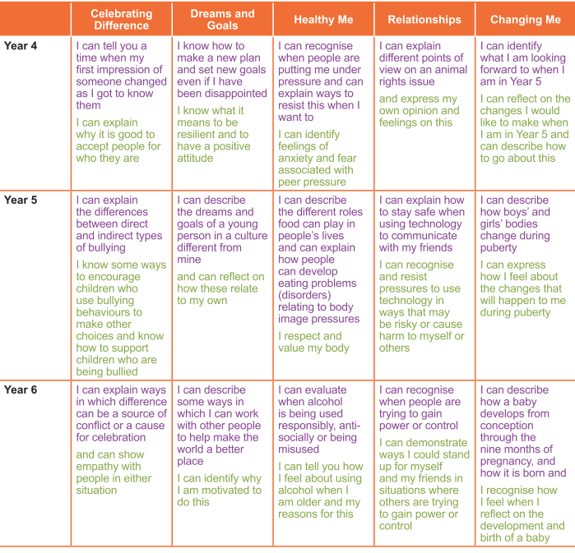
The SRE programme is Assessed, Monitored and Evaluated
Assessment examples:
- Questionnaire
- Discussion
- Teacher assessments
- Pupils’ self assessment
- Staff assessment
- Progress is included (PSHCE) in the pupils’ annual report
- Evaluations used by the co-ordinator to inform future planning.

Monitoring:
PSHCE, including SRE is monitored through the school’s programme of lesson observations, learning walks, book evaluations, discussions with children
Evaluation:
The programme is evaluated to ensure it meets the changing needs of the young people and reflects the views and values of the school community; this is carried out by teachers and pupils.

Working with Parents and Carers
Dry Sandford Primary School will keep parents/carers informed of the SRE programme.

We recognise that parents and carers have an especially important role to play in SRE as they need to feel confident that our programme complements and supports their role. To enable this, an information session for parents of children in Year 6 is held to discuss the SRE programme. Materials are available to parents/carers who wish to supplement the school’s SRE programme or wish to deliver the SRE programme at home.
Up to date copies of this policy will be available on the school website. Parents will be given opportunity to discuss an queries or concerns with the teacher.
Parents have a right to withdraw their children for SRE lessons and therefore there will be a form for parents to complete and return to the school stating if they would like their children withdrawn from these lessons.
Specific issues with SRE
- What kind of language will be considered acceptable and appropriate for use in SRE lessons?
All Staff will:
- Use the correct terms for all body parts as this is deemed good practice.
- Openly teach pupils what ‘slang’ words mean (where appropriate), and that some are offensive.
- Avoid using the use of any slang.
- Safeguarding
- SRE may bring about disclosures of safeguarding children issues and all staff are conversant with the policies and procedures for reporting their concerns.
- Confidentiality
- As a general rule, a child’s confidentiality is maintained by the teacher or member of staff concerned. If this person believe that the child is at risk or in danger, the talk to the named child protection co-ordinator who may report this to the Local Authority Safeguarding Team (MASH).
Working with outside agencies
Dry Sandford Primary School may use the expertise of outside agencies

Occasionally, appropriate and suitable experienced and/ or knowledgeable visitors from outside the school may be invited to contribute to the delivery of SRE at the school.
SRE Policy monitoring and review
Date of completion: November 2016

Date of review: November 2021/ Nov 2023

Signed:
Headteacher: Lisa Moorhouse
Governor Lead: David Murphy

